Reservation Form 预订单（中文版）

Name 姓名 :
Telephone 电话 :
Email address 邮件 :
Check In Date 入住日期 :
Check Out Date 退房日期 :
Room type 房间类型:
No. of Room (s) 房间数 :
No. of Guest (s) 房客数 :

👇无需填写 No need to fill
Type of Credit Card: ( ) VISA ( ) MASTER ( ) Other……….
Credit Card No. : Expiry date :
CCV no. :
I hereby agree and authorize that to be charged to my credit card as indicated above.
Card Holder Signature :
Full Name as it appears :
👆无需填写 No need to fill

Rate 价格:
Deluxe Ocean View (48 sq.m) with Balcony  豪华海景房（48平米/带阳台） | 3,700 THB per room per night inclusive taxes and BF for 2 pax 每间泰铢3700含双早
Pool Suite Room (80 sq.m) with Private Pool  泳池套房（80平米/带私人泳池） | 4,600 THB per room per night inclusive taxes and BF for 2 pax 每间泰铢4600含双早
Pool Suite Ocean View (80 sq.m) with Private Pool and Ocean View  海景泳池套房（80平米/带私人泳池） | 5,000 THB per room per night inclusive taxes and BF for 2 pax 每间泰铢5000含双早

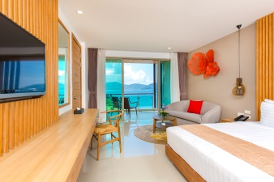  Deluxe Ocean View  豪华海景房 | 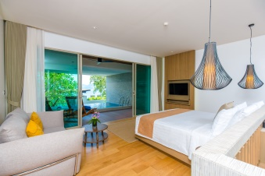  Pool Suite Room  泳池套房 | 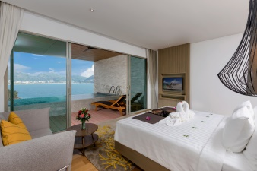  Pool Suite Ocean View  海景泳池套房

The rate is per room per night, inclusive of:价格包含
- 10% service charges and 7% VAT. 服务费税费
- Daily buffet breakfast. 自助早餐
- Free Wi-Fi internet in all guest rooms, conference rooms, lobby area, restaurants & bars. 无线网
- Free usage of swimming pool. 泳池使用

Check-in & Check out Time: 入住退房时间政策
- Check in policy is from 14:00 onwards, check-out time is before 12:00 noon.
入住时间从当日14:00开始，退房时间在当日正午12:00之前
- Early check in or late check-out is confirmed based on availability on the day of check-out and the following charges is applied: prior to 18.00 hours is 50% of applicable room rate and after 18.00 hours is 100% 迟退房在当日房间允许情况下是可以发生的，但是会产生相应的费用。18.00前加收半价房费，18.00后加收全价房费。

Please complete the Reservation Form and e-mail direct to hotel reservation at reservations@wyndhamgrandphuket.com

Your Sincerely,
Supapich Akrahirunpatt
Senior Sales Manager
Wyndham Grand Phuket Kalim Bay
Mobile: +66 94 364 6445

